**CS5590_Python-MachineLearning - LAB ASSIGNMENT 1**

**Name: DEVENDER SARDA**

**SSO ID: dspc8**

**UMKC Student ID: 16243492**

**Class ID: 45**

***

**Objective**

The following assignment focus on to make one familiar with python basic topics.

**Features**

Uses Python basic concepts including loops, list and tuples to do the desired tasks

**Configuration**

JetBrains PyCharm and Python 3.6.4

**Task 1**

[Task1_Password - Code Snippet]

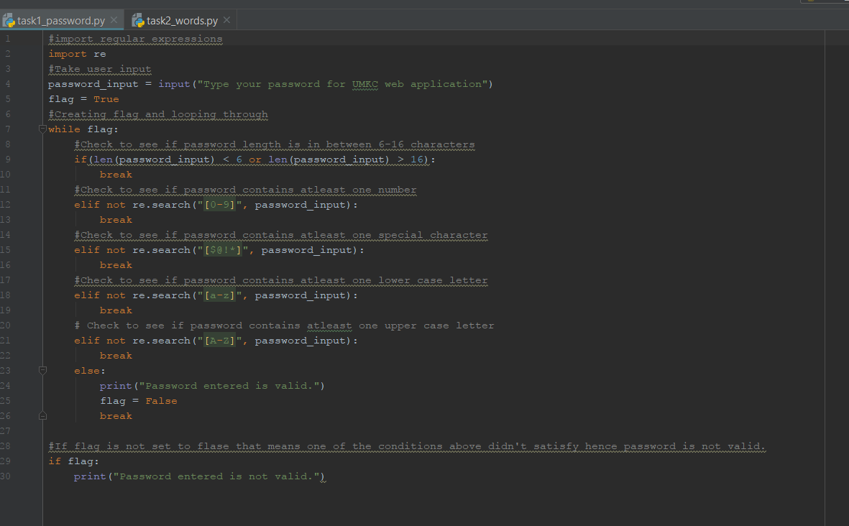

[Task1_Password - Output Valid]

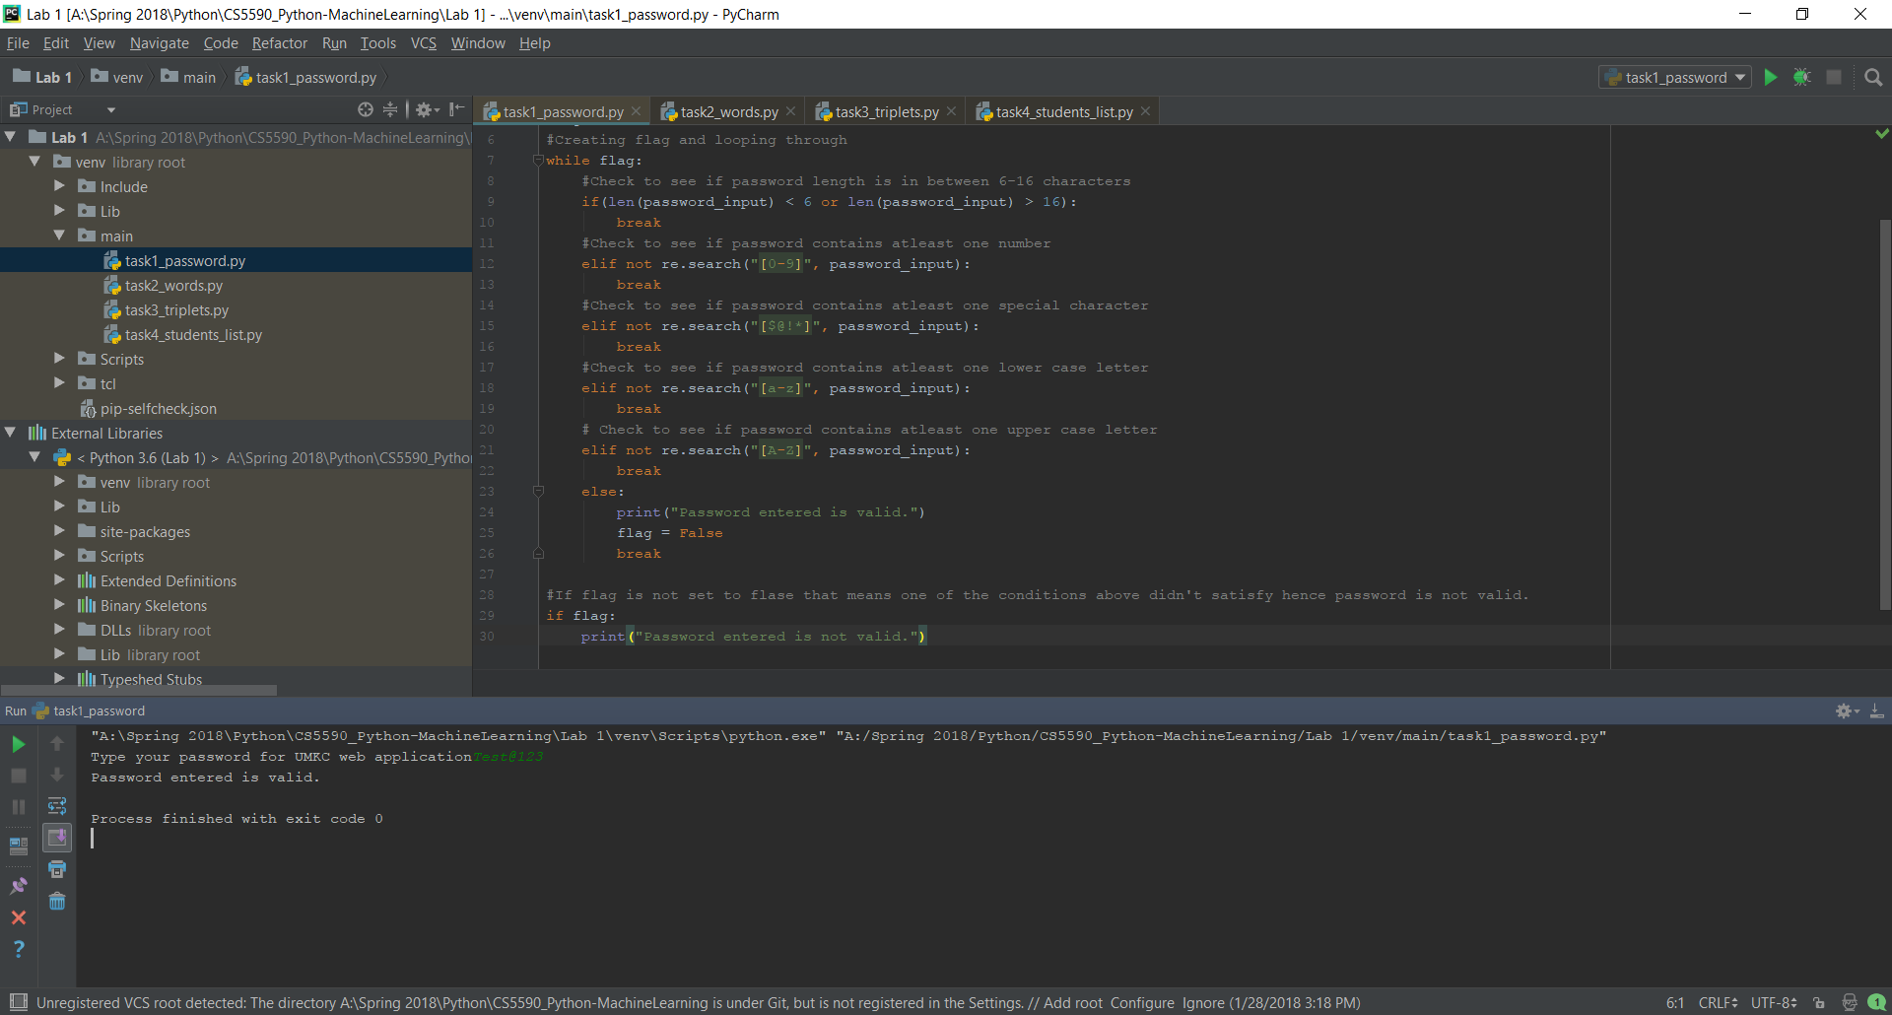

[Task1_Password - Output Invalid]

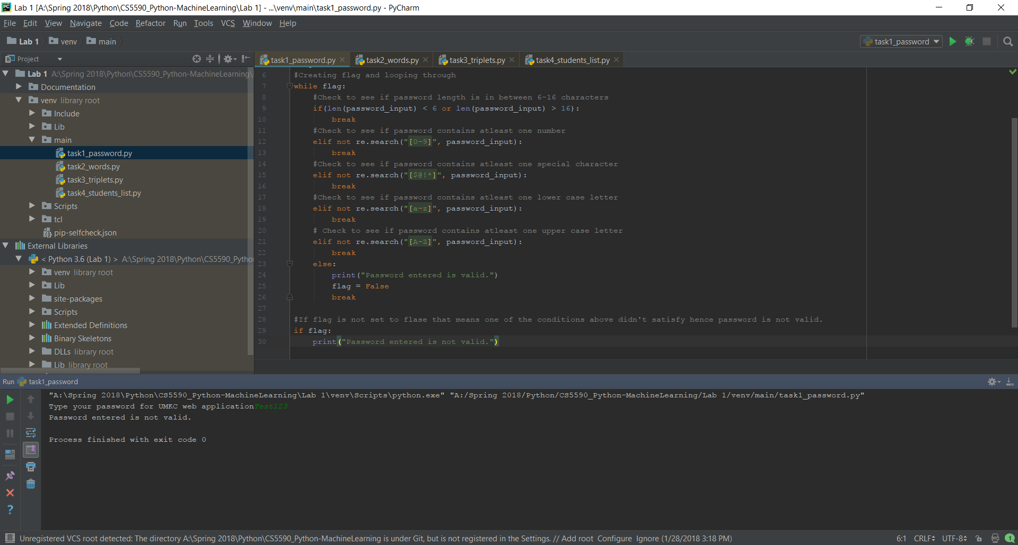

**Task 2*

[Task2_Words - Code Snippet]

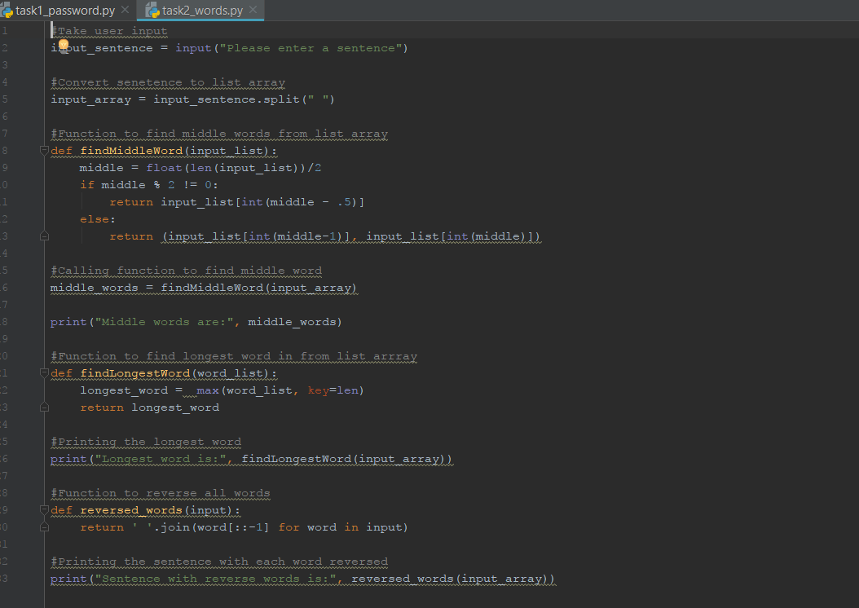

[Task2_Words - Output]

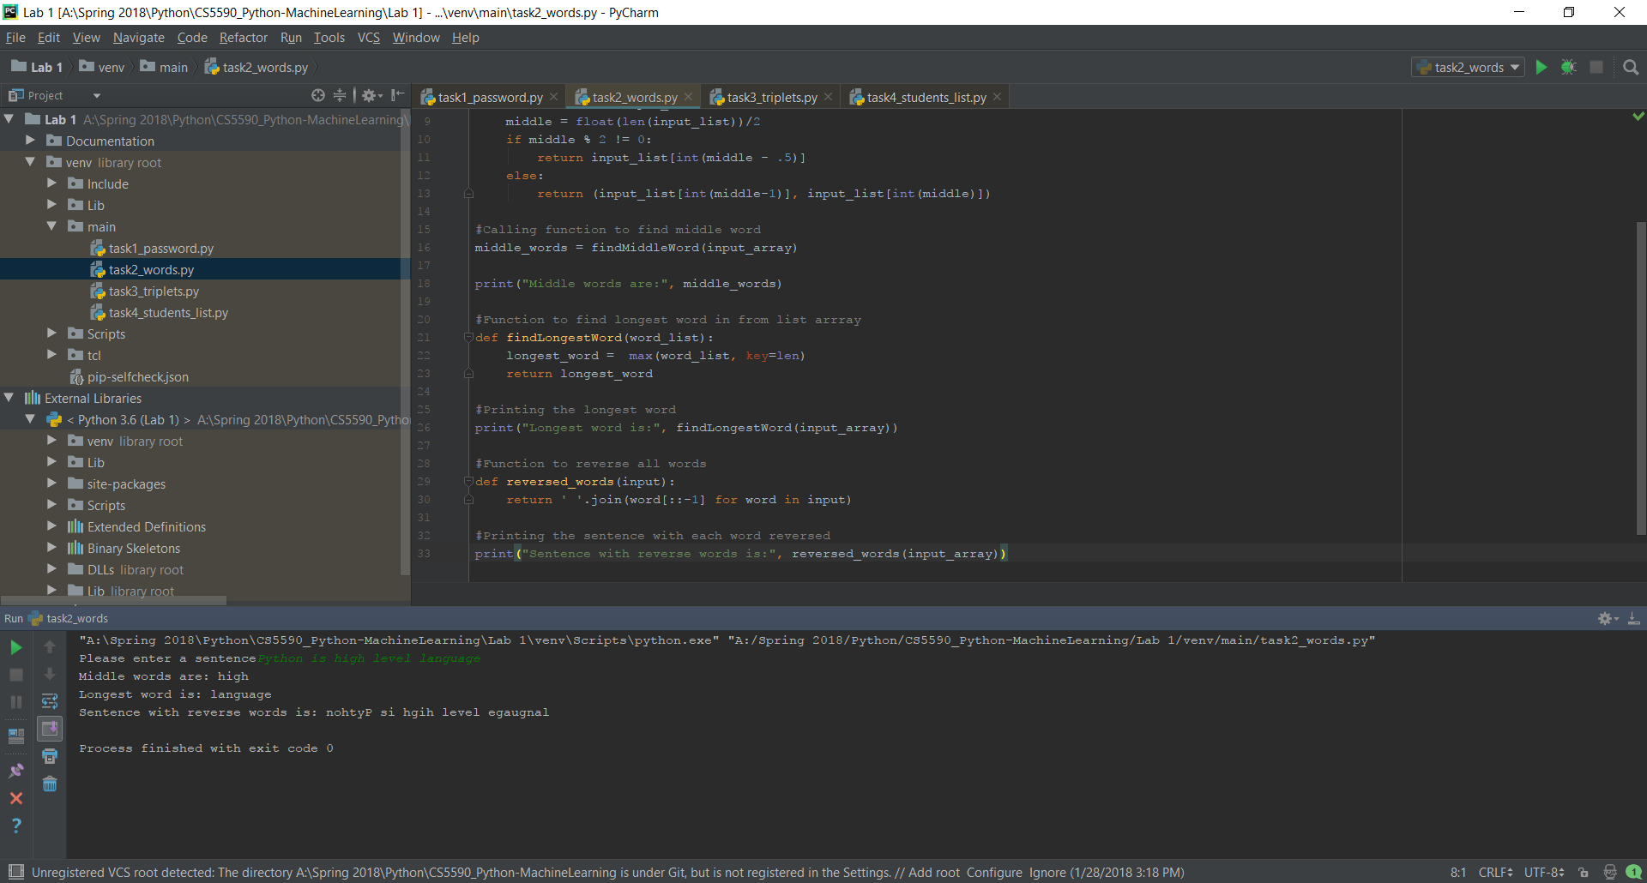

**Task 3**

[Task3_triplets - Code Snippet]

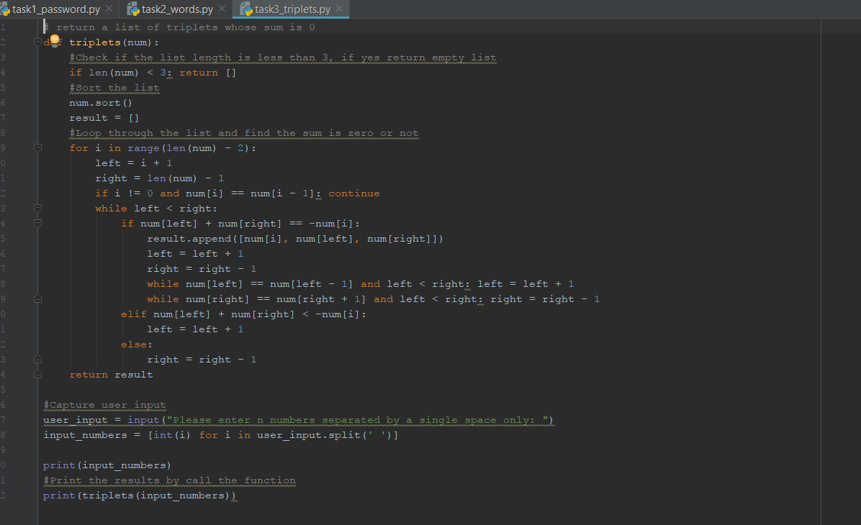

[Task3_triplets - Output]

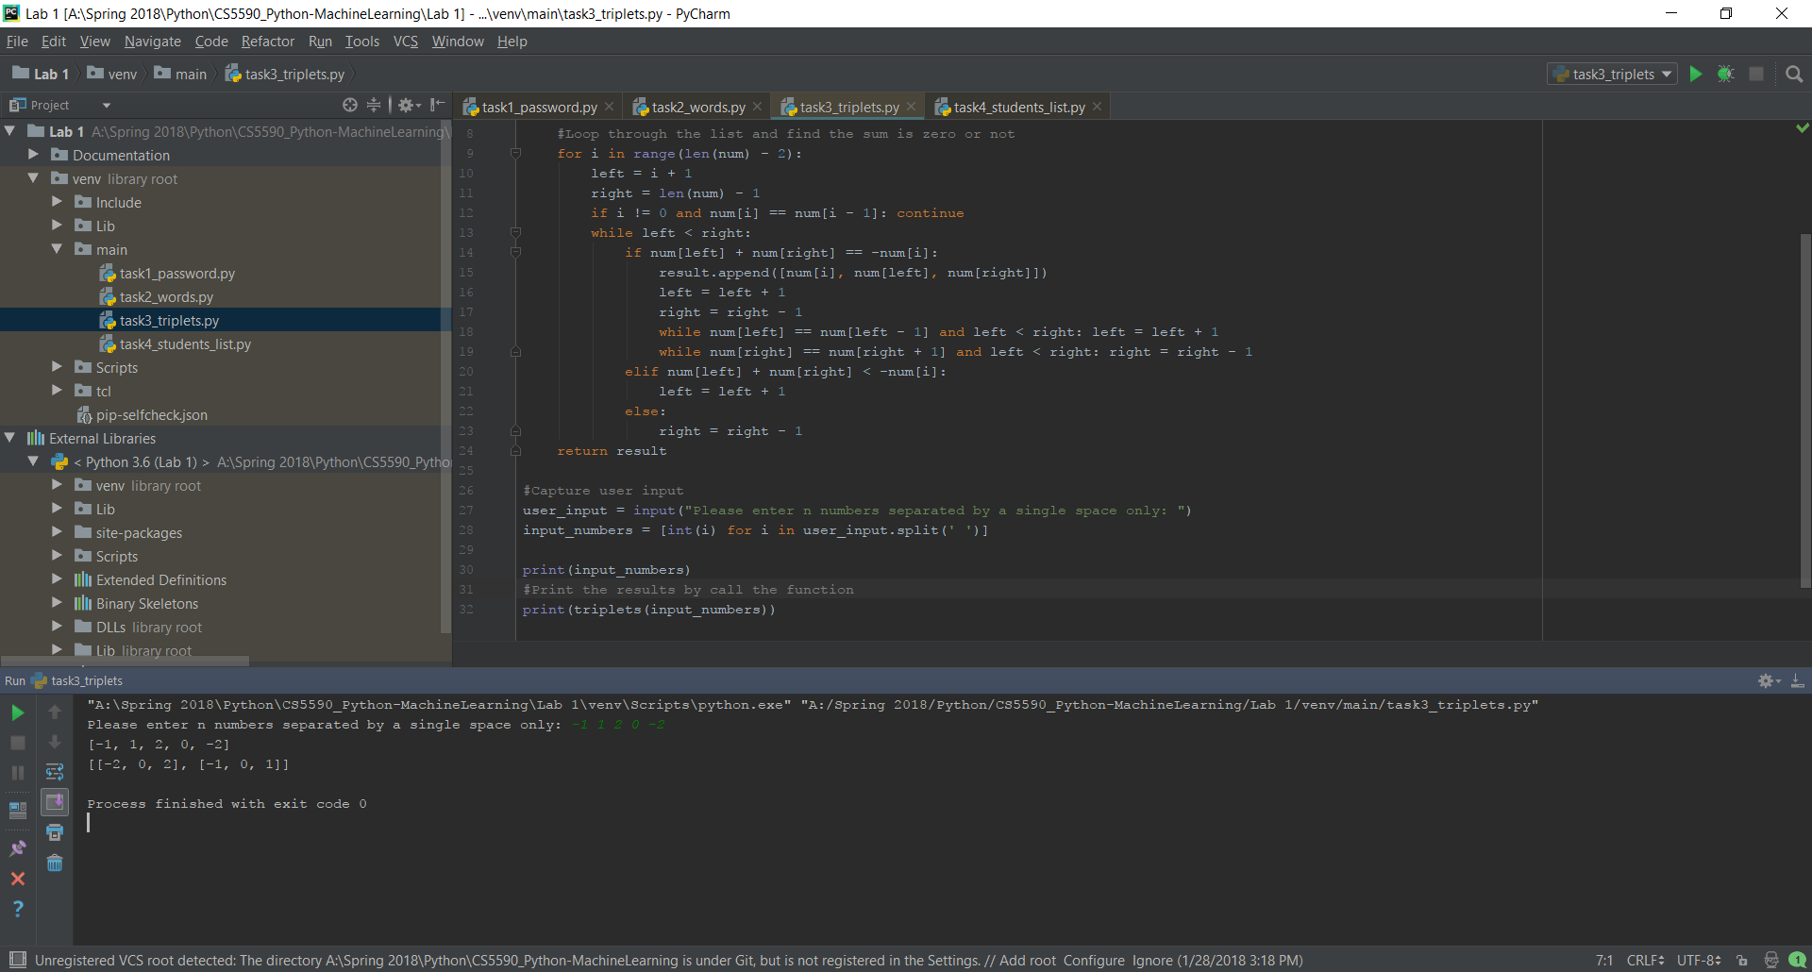

**Task 4**

[Task4_students_list - Code Snippet]

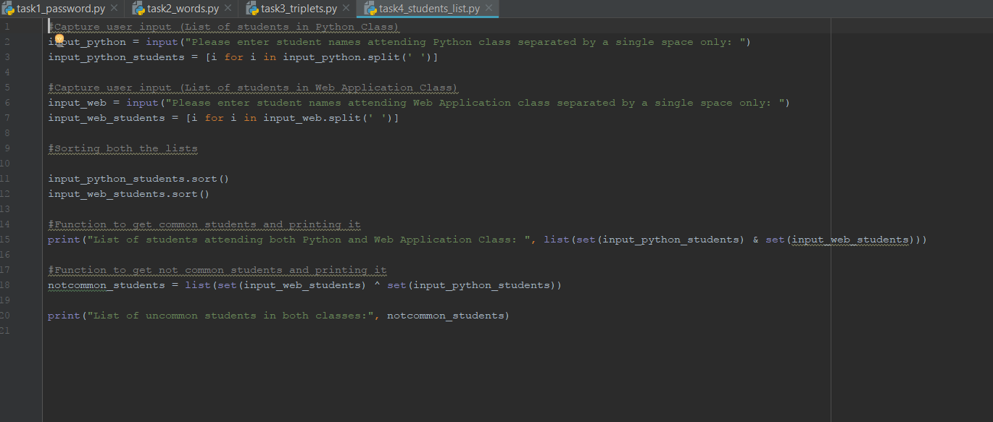

[Task4_students_list – Output]



